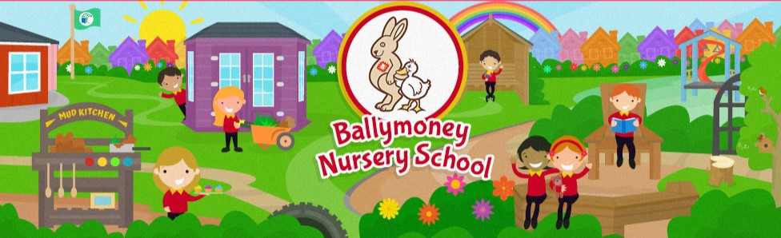

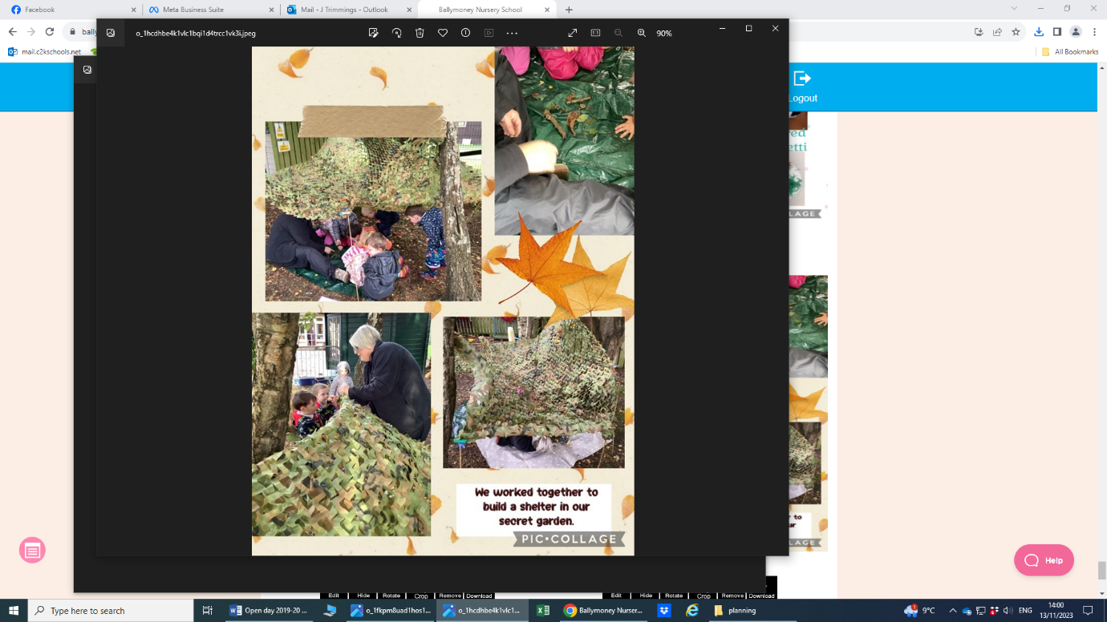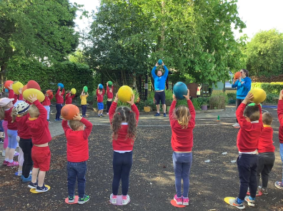

**Will be holding an**

**Open Day**

on **Wednesday 29th November 2023**

**11:30 am-12:30 pm**

**and**

**6:00 pm-7:00 pm**

**We look forward to seeing you all there –**

**Everyone is Welcome!**

**Applications can be made online at www.eani.org.uk from 9th January 2024**

For further details on how to obtain a free place 5 days a week (pre-schoolers and if availability pre-pre schoolers) please come along to the open day or contact the Nursery Team on 028 276 64367

**Pre-Schoolers – born between 2/7/20- 1/7/21**

**Pre-Pre Schoolers – born between 2/7/21 – 1/7/22**

*Please contact the Nursery for Deferred Children*



